**Commands Practiced in class**

1. a1 **“Cloudera”** is user name used to login into linux  
   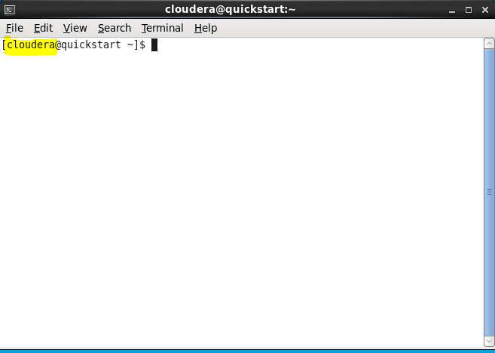

a2 Can also see by command **“whoami”**



1. b1 “**Quickstart**” Host name of operating system

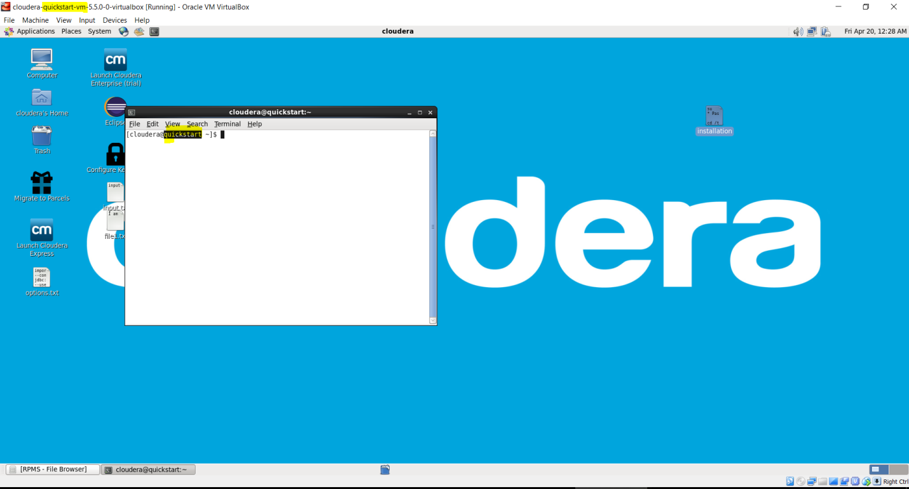

b2 Can also see Hostname by command “**hostname**”

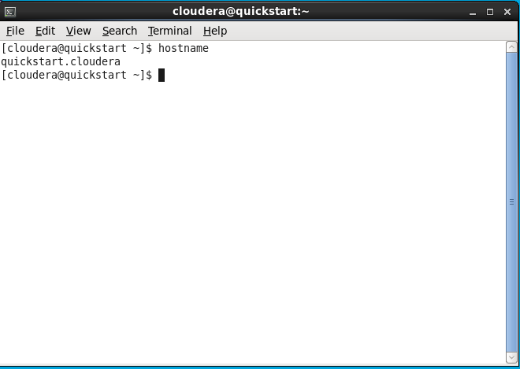

1. ~ (tilt) indicates home directory

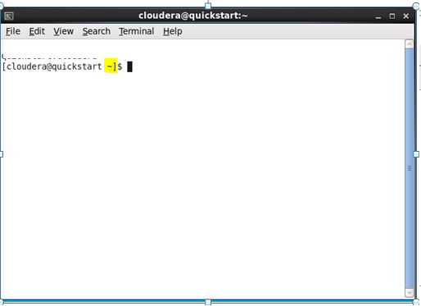

1. Pwd = Present Working Directory



### [ls = list file and directory names and attributes](https://www.mkssoftware.com/docs/man1/ls.1.asp)

|  |  |
| --- | --- |
| option | description |
| [ls -a](https://www.rapidtables.com/code/linux/ls/ls-a.html) | **list all files including hidden file starting with '.'** |
| ls --color | colored list [=always/never/auto] |
| ls -d | list directories - with ' */' |
| ls -F | add one char of */=>@| to enteries |
| ls -i | list file's inode index number |
| [ls -l](https://www.rapidtables.com/code/linux/ls/ls-l.html) | **list with long format - show permissions** |
| [ls -la](https://www.rapidtables.com/code/linux/ls/ls-l.html) | **list long format including hidden files** |
| [ls -lh](https://www.rapidtables.com/code/linux/ls/ls-l.html) | list long format with readable file size |
| [ls -ls](https://www.rapidtables.com/code/linux/ls/ls-l.html) | list with long format with file size |
| [ls -r](https://www.rapidtables.com/code/linux/ls/ls-r.html#reverse) | list in reverse order |
| [ls -R](https://www.rapidtables.com/code/linux/ls/ls-r.html#recursive) | list recursively directory tree |
| [ls -s](https://www.rapidtables.com/code/linux/ls/ls-s.html#size) | **list file size** |
| [ls -S](https://www.rapidtables.com/code/linux/ls/ls-s.html#sort-size) | **sort by file size** |
| [ls -t](https://www.rapidtables.com/code/linux/ls/ls-t.html) | **sort by time & date** |
| **ls -X** | **sort by extension name** |

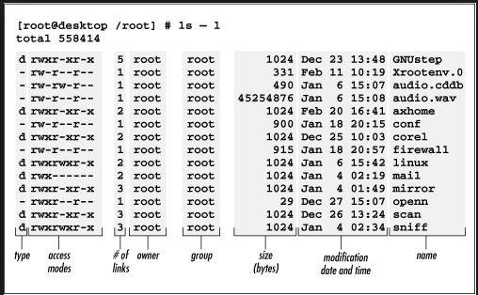

‘’.’’ Prefix files are hidden files in linux. Command to see hiden files is ‘’ls –a’’

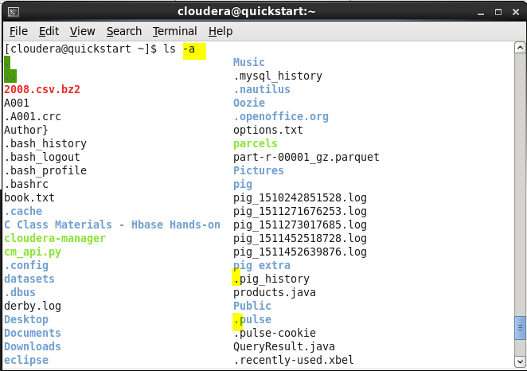

‘’ctrl + h ‘’ to see hidden files in window

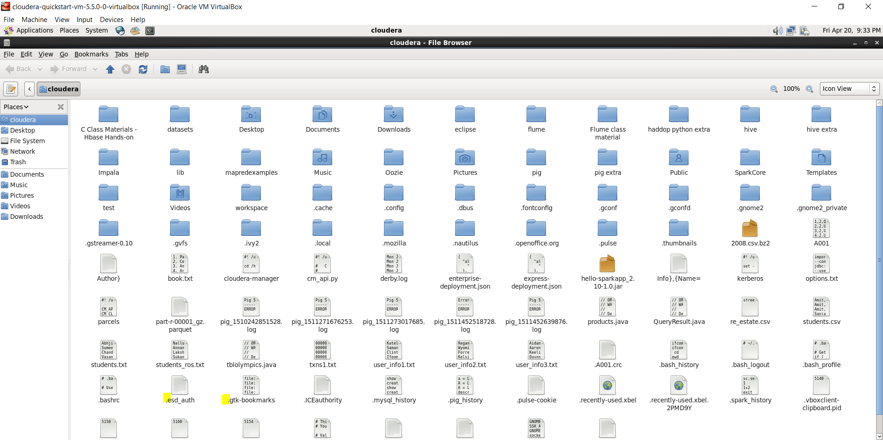

Most frequently used command. List with alt “ls –altr” (a-all files including hidden, l-list user, t- sort by last use) r (reverse)

1. Jps- (with sudo) java virtual machine process status

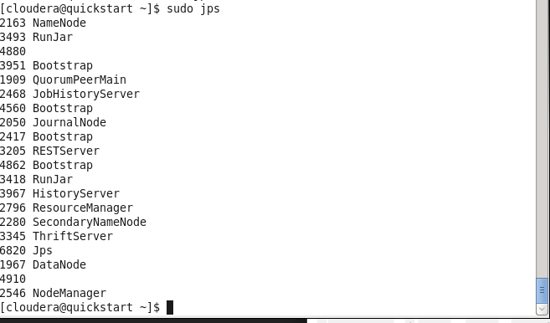

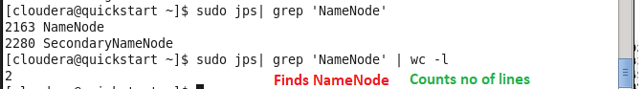

1. Cd – Change Directory

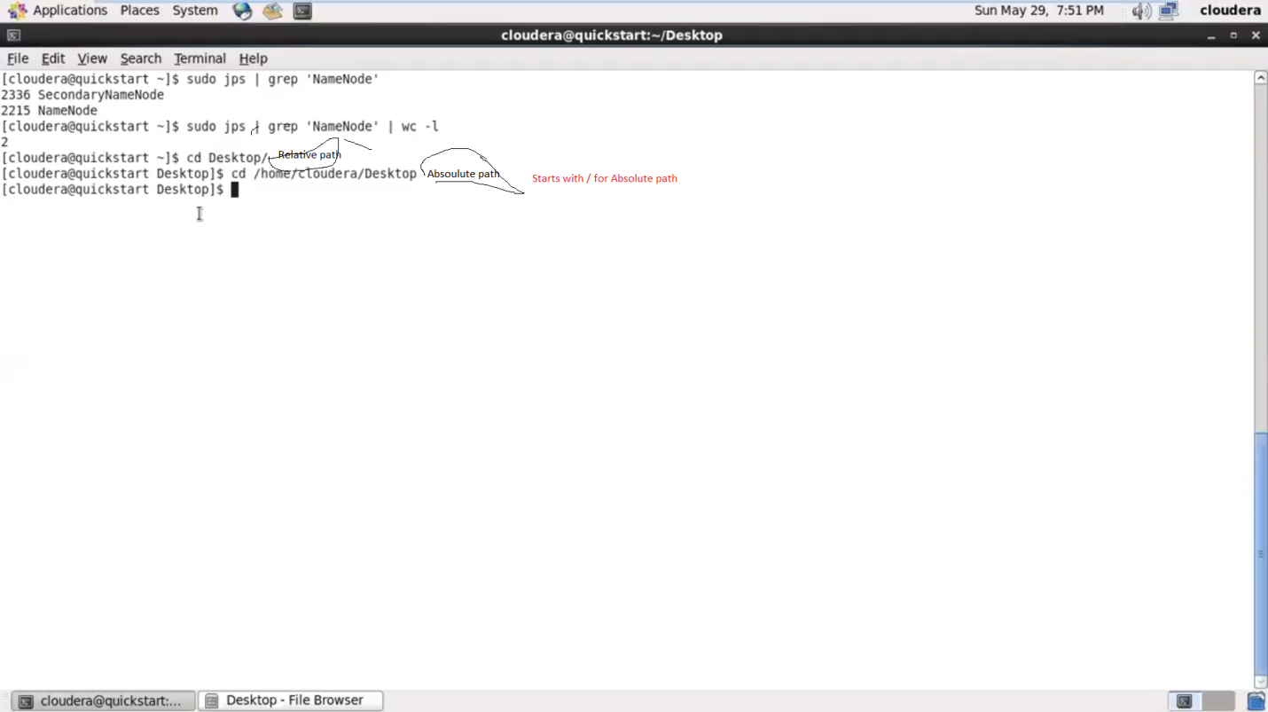

Always use absolute path in script. Safest

1. Man – Manual and info - Info

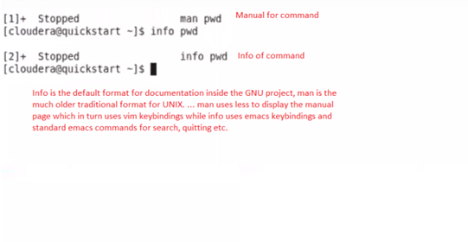

**Info** is the default format for documentation inside the GNU project, **man** is the much older traditional format for UNIX. ... **man** uses less to display the manual page which in turn uses vim keybindings while **info** uses emacs keybindings and standard emacs **commands** for search, quitting etc.

To come out ‘’ctrl ++ z’’

1. Cat – Creating and Viewing file

Display, Copy, Combine and create new text file.

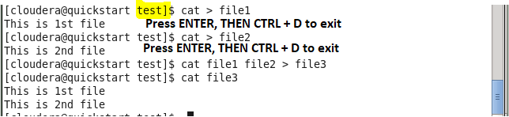

1. Rm – Remove file 
2. Mv – Move/ Rename ( File and Directory both)

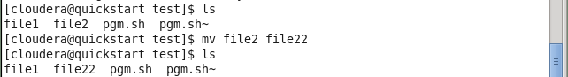

Renamed file2 to file22

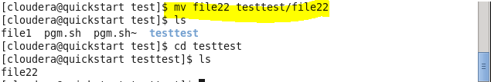

Moved /test/file22 to /test/testtest/file22

1. Su – supper user ( Should know supper user password



* Password is cloudera

1. Sudo prefix to command – Do as super-user. Commands executed are logged. Enter own password. Password is retained for 15 mins as super user.



1. Mkdir – Create directory



1. Rmdir – remove directory



1. History – List of commands executed

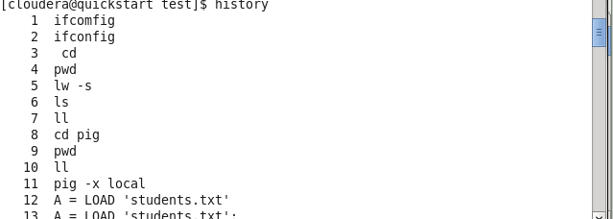

1. Clear – Clear the window



1. Chown – Change owner

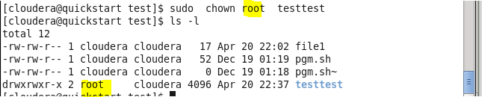

1. Chmod – Change mode/authority

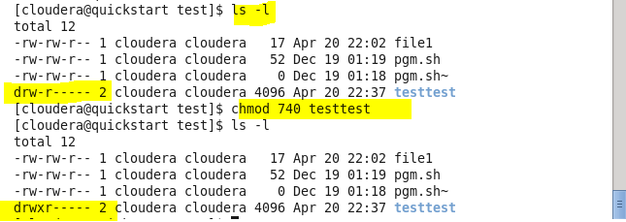

Owner, Group and Other permission

R – 4, w – 2, e – 1

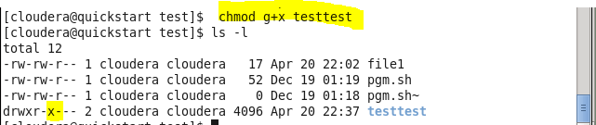

It’s the other way

+ to add, – to remove

u user/owner, g-group, o-other and a –all

1. Chgrp – change group

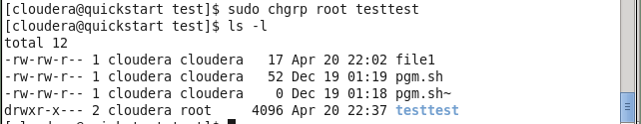

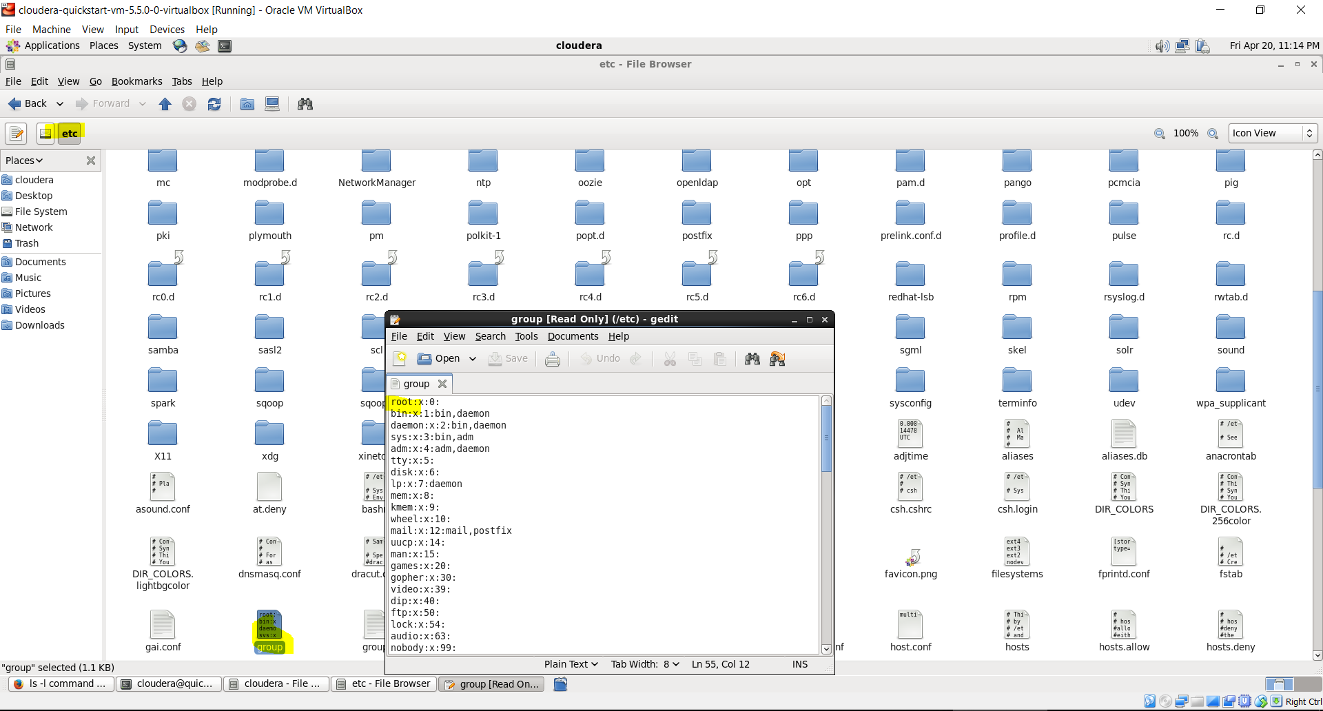

All groups are here0

Note: *** ‘’ctrl + c’’ kills process. To copy ‘’ctrl + shft + c’’ and to paste ‘’ctrl + shft + v’’

**What is Shell Scripting ?**

Simply it is another program where you can give commands in text mode to get some work done.

However you can write a sequence of commands in a file and tell the shell to execute those commands. Then those files are called shell scripts. (File extension is .sh)

Such a script can be defined as a specific command defined to get a specific work done.

Shell scripting is very useful in a way that, if you want to do a task again and again then you can write the required commands as a shell script and execute it.

Ok, now let's try a simple shell script.

A Simple Shell Script

BASH is the default shell for Linux. Let's script using BASH commands. First we will write a simple script to print "Hello world ! " in the terminal.

You can use any text editor (gedit, vi, emacs, etc.) to write a shell script. Remember the script should be saved with .sh extension.

Write the following lines in a file and save it as 'hello.sh'.

#!/bin/bash

echo "Hello, World!"

or explain ‘pgm.sh’

echo “Hello, What is yout Name”

read name

echo “$name, nice name”

Now you can execute this hello.sh script.

1. Open a terminal
2. Go to the location where you've saved the above file
3. Then to execute, type, sh hello.sh (Or else you can give execution permission to the above file and then execute it.)

If you have a little touch with shell commands you know the above line no. 2 is enough for printing "Hello, World" in the terminal. So why do we include line no.1 's content ?

It is called a shebang or a "bang" line. In this line we give the absolute path to the BASH interpreter.

Shebang includes the hash sign and an exclamation point character (#!), followed by the full path to the interpreter such as /bin/bash. This will ensure that, the script is using the specified BASH interpreter even if it is executed under another shell.

Note : Giving execution permission to the script.

To give the execution permission to the file you can use the following command.

>> chmod +x /path to file

This is a very simple shell script. We can do a lot of things using shell scripting. Hope to bring them one by one in my next posts.

**How to install software’s (eg: open office/libreoffice):**

* **su**

**\* Password is cloudera**

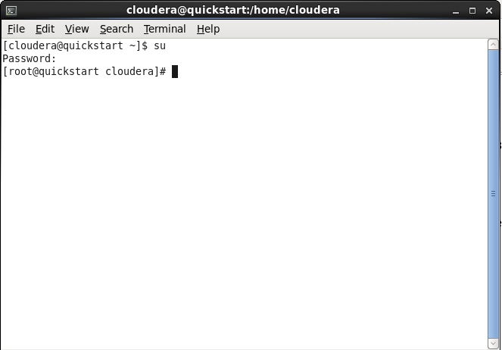

* **cd /tmp**



* **wget http://download.services.openoffice.org/files/stable/3.3.0/OOo_3.3.0_Linux_x86-64_install-rpm-wJRE_en-US.tar.gz**

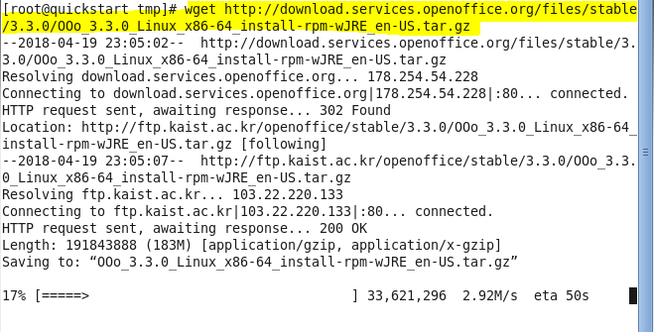

* **tar -zxvf OOo_3.3.0_Linux_x86-64_install-rpm-wJRE_en-US.tar.gz**

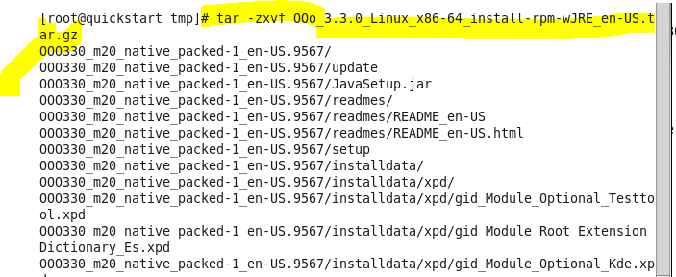

* **rpm -Uvh OOO330_m20_native_packed-1_en-US.9567/RPMS/*.rpm**



* **rpm -Uvh OOO330_m20_native_packed-1_en-US.9567/RPMS/desktop-integration/openoffice.org3.3-redhat-menus-3.3-9556.noarch.rpm**

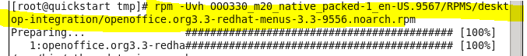

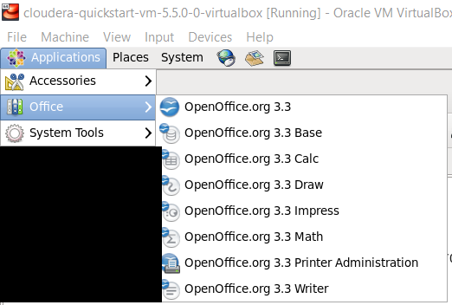

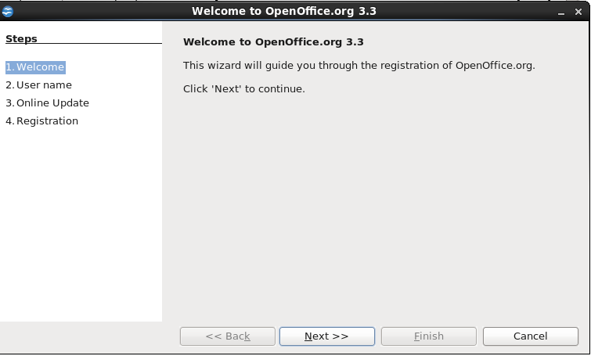

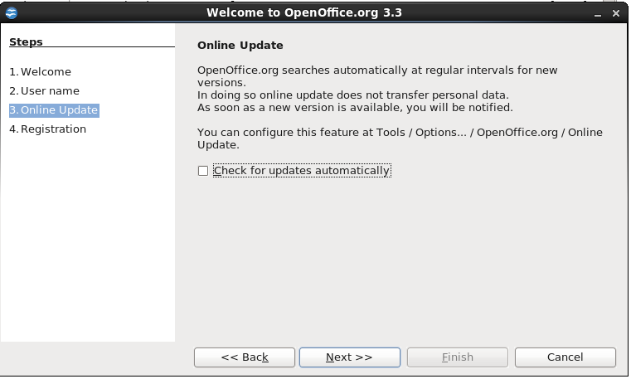

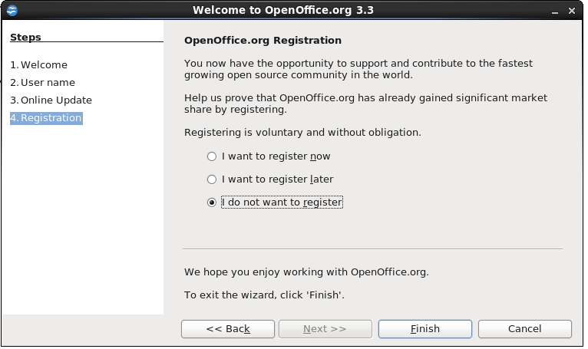

Note: If says already installed and not showing, force rpm command by rpm -Uvh --nodeps –force

**Note:** Can also be install software by command “yum install libreoffice”

**How to uninstall software’s (eg: open office/libreoffice):**

**Code:**

$rpm -qa | grep -i openoffice

**That produces the following output,**

openoffice.org3-math-3.3.0-9567.x86_64

openoffice.org3-en-US-3.3.0-9567.x86_64

openoffice.org3-dict-es-3.3.0-9567.x86_64

openoffice.org3-base-3.3.0-9567.x86_64

openoffice.org3-3.3.0-9567.x86_64

openoffice.org3-draw-3.3.0-9567.x86_64

openoffice.org3.3-redhat-menus-3.3-9556.noarch

openoffice.org3-dict-en-3.3.0-9567.x86_64

openoffice.org3-impress-3.3.0-9567.x86_64

openoffice.org-ure-1.7.0-9567.x86_64

**If you get similar results, uninstall OpenOffice by doing**

#rpm -e openoffice.org3-math

.

.

and so on

**Note:** Can also be uninstalled software by command “yum remove libreoffice*”